HW3-Darshan Patel-3:30-5:30PM

Darshan Patel

10/18/2018

In the beginning of the 17th century, John Graunt wanted to determine the effect of the plague ont he population of England; two hundred years later, Pierre-Simon Laplace wanted to estimate the population of France. Both Graunt and Laplace implemented what is now called the capture-recapture methood. This technique is used to not only count human populations (such as the homeless) but also animals in the wild.

In its simplest form, $n_{1}$ individuals are “captured,” “tagged,”" and released. A while later, $n_{2}$ individuals are “captured” and the number of “tagged” individuals, $m_{2}$ is counted. If $N$ is the true total population size, we can estimate it with ${\overset{^}{N}}_{LP}$ as follows:

$${\overset{^}{N}}_{LP}=\frac{n_{1}n_{2}}{m_{2}}$$

using the relation

$$\frac{n_{1}}{N}=\frac{m_{2}}{n_{2}}$$

This is called the Lincoln-Peterson estimator.

We make several strong assumptions when we use this method: (a) each individual is independently captured, (b) each individual is equally likely to be captured, (c) there are no births, deaths, immigration, or emigration of individuals (i.e., a closed population), and (d) the tags do not wear off (if it is a physical mark) and no tag goes unnoticed by a researcher.

*Goal:* In this assignment, you will develop a Monte-Carlo simulation of the capture-recapture method and investigate the statistical properties of the Lincoln-Peterson and Chapman estimators of population size $N$. (Since you are simulating your own data, you know the true value of the population size $N$ allowing you to study how well these estimators work.)

# Import libraries  
library(tidyverse)

## ── Attaching packages ─────────────────────────────────────────────────────────────────────────────────────────────────────────────────────────────────────────────────────────────────────────────────────────────────────────────────────── tidyverse 1.2.1 ──

## ✔ ggplot2 2.2.1 ✔ purrr 0.2.5  
## ✔ tibble 1.4.2 ✔ dplyr 0.7.6  
## ✔ tidyr 0.8.1 ✔ stringr 1.3.0  
## ✔ readr 1.1.1 ✔ forcats 0.3.0

## Warning: package 'tidyr' was built under R version 3.4.4

## Warning: package 'purrr' was built under R version 3.4.4

## Warning: package 'dplyr' was built under R version 3.4.4

## ── Conflicts ────────────────────────────────────────────────────────────────────────────────────────────────────────────────────────────────────────────────────────────────────────────────────────────────────────────────────────── tidyverse_conflicts() ──  
## ✖ dplyr::filter() masks stats::filter()  
## ✖ dplyr::lag() masks stats::lag()

## Question 1:

Simulate the capture-recapture method for a population of size $N=5,000$ when $n_{1}=100$ and $n_{2}=100$ using the sample() function (assume that each individual is equally likely to be “captured”). Determine $m_{2}$ and calculate ${\overset{^}{N}}_{LP}$.

Answer:

# Create variables  
n <- 5000  
n_1 <- 100  
n_2 <- 100  
  
# Sample the captured points  
cap_one <- sample(1:n, n_1, replace = FALSE)  
cap_two <- sample(1:n, n_2, replace = FALSE)  
  
# Calculate m_2 and N_LP  
m_2 <- length(intersect(cap_one, cap_two))  
N_LP <- n_1 * n_2 / m_2  
paste("m_2:", m_2, sep = ' ')

## [1] "m_2: 1"

paste("N_LP:", N_LP, sep = ' ')

## [1] "N_LP: 10000"

## Question 2:

Write a function to simulate the capture-recapture procedure using the inputs: $N$, $n_{1}$. $n_{2}$ and the number of simulation runs. The function should output in list form (a) a data frame with two columns: the values of $m_{2}$ and ${\overset{^}{N}}_{LP}$ for each iteration and (b) $N$. Run your simulation for $1,000$ iterations for a population of size $N=5,000$ where $n_{1}=n_{2}=100$ and make a histogram of the resulting ${\overset{^}{N}}_{LP}$ vector. Indicate $N$ on the plot.

Answer:

# Function to simulate the capture-recapture procedure using the inputs: N, n_1, n_2 and number of simulation runs  
capture_recapture = function(N, n_1, n_2, runs){  
   
 # Create vector to store m_2s and N_LPs  
 m_2 <- c()  
 N_LP <- c()  
   
 # For each run, perform the capture-recapture procedure   
 for(i in 1:runs){  
   
 # Sample the captured points   
 cap_one <- sample(1:N, n_1, replace = FALSE)  
 cap_two <- sample(1:N, n_2, replace = FALSE)  
   
 # Finds the points that are recaptured   
 recaptured <- length(intersect(cap_one, cap_two))  
   
 # Append to m_2 vector  
 m_2 <- c(m_2, recaptured)  
   
 # Calculate N_LP and append to its vector   
 N_LP <- c(N_LP, (n_1 * n_2 / recaptured))  
 }  
   
 # Return a list where the first element is a dataframe of m_2 and N_LP   
 # and the second element is the actual N  
 return(list(df = data.frame(m_2, N_LP), N = N))  
}

Simulation:

# Perform a simulation using 1000 runs  
simulation <- capture_recapture(5000, 100, 100, 1000)  
df <- simulation$df  
  
# Plot a histogram of the calculated N_LP values  
ggplot(df, aes(x = df$N_LP)) + geom_histogram(color = "darkblue", fill = "lightblue") + ggtitle("Calculated N_LP value from \n Simulation of Capture-Recapture Procedure") + geom_vline(aes(xintercept = 5000), color = "black", linetype = "dashed") + geom_text(aes(x = simulation$N - 800, y = 280, label = "actual N")) + labs(x = "N_LP")

## `stat_bin()` using `bins = 30`. Pick better value with `binwidth`.

## Warning: Removed 144 rows containing non-finite values (stat_bin).

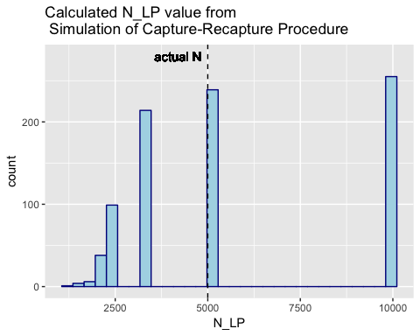

## Question 3:

What percent of the estimated population values in Question 2 were infinite? Why can this occur?

Answer:

per_inf <- paste(100 * length(which(is.infinite(simulation$df$N_LP))) / nrow(simulation$df), "%", sep = ' ')  
per_inf

## [1] "14.4 %"

The percentage of infinite $N_{LP}$ calculated is 14.4 %. This occurs because in some rare cases, there was no recapture of any points, meaning $m_{2}=0$. Thus in the calculation of $N_{LP}$, there is a $0$ in the denominator, causing R to give an infinite result.

## Question 4:

An alternative to the Lincoln-Peterson estimator is the Chapman estimator:

$${\overset{^}{N}}_{C}=\frac{(n_{1}+1)(n_{2}+1)}{m_{2}+1}−1$$

Use the saved $m_{2}$ values from question 2 to compute the corresponding Chapman estimates for each iteration of your simulation. Construct a histogram of the resulting ${\overset{^}{N}}_{C}$ estimates, indicating $N$ on the plot.

Answer:

# Calculate N_C from the m_2 values from the previous simulation runs   
N_C <- data.frame(chapman = (((n_1 + 1)*(n_2 + 1))/(simulation$df$m_2 + 1)) - 1)  
  
# Plot a histogram of the calculated N_C values  
ggplot(N_C, aes(x = N_C$chapman)) + geom_histogram(color = "steelblue4", fill = "skyblue") + ggtitle("Calculated N_C from \n Simulation of Capture-Recapture Procedure") + geom_vline(aes(xintercept = 5000), color = "black", linetype = "dashed") + geom_text(aes(x = simulation$N - 800, y = 300, label = "actual N")) + labs(x = "N_C")

## `stat_bin()` using `bins = 30`. Pick better value with `binwidth`.

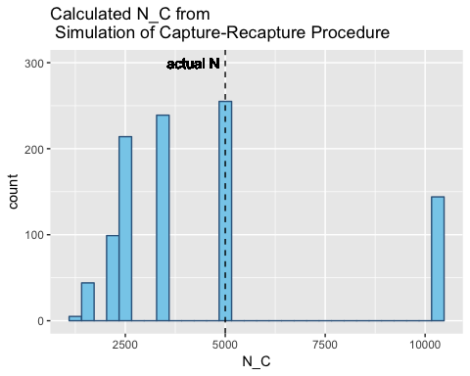

## Question 5:

An estimator is considered *unbiased* if, on average, the estimator equals the true population value. For example, the sample mean $\overline{x}=\sum_{i=1}^{n}{x_{i}}/n$ is unbiased because on average the sample mean $\overline{x}$ equals the population mean $μ$ (i.e., the sampling distribution is centered around $μ$). This is a desirable property for an estimator to have because it means our estimator is not systematically wrong. To show that an estimator $\overset{^}{θ}$ is an unbiased estimator of the true value $θ$, we would need to mathematically prove that $E[\overset{^}{θ}]−θ=0$ where $E[⋅]$ is the expectation (i.e., theoretical average). Instead, we will investigate this property empirically by replacing the theoretical average $E[\overset{^}{θ}]$ with the sample average of the $\overset{^}{θ}$ values from our simulation (i.e., $\sum_{i=1}^{n_{sim}}{\overset{^}{θ}}/n_{sim}$ where $n_{sim}$ is the number of simulation runs; $θ$ is $N$ in this case and $\overset{^}{θ}$ is either ${\overset{^}{N}}_{LP}$ or ${\overset{^}{N}}_{C}$ as both are ways to estimate $N$).

Estimate the bias of the Lincoln-Peterson and Chapman estimators based on the results of your simulation. Is either estimator unbiased when $n_{1},n_{2}=100$?

Answer: Note that to compute the mean of $N_{L}P$, the infinites should be ignored and $n_{sim}$ should be properly instated.

# Isolate the finite N_LP values  
N_LP_finite <- simulation$df$N_LP[is.finite(simulation$df$N_LP)]  
  
# Calculate the bias of N_LP  
bias_LP <- mean(N_LP_finite) / length(N_LP_finite)  
  
# Calculate the bias of N_C  
bias_chapman <- mean(N_C[,1]) / length(N_C[,1])  
paste("The bias of the Lincoln-Peterson estimator is", bias_LP, sep = ' ')

## [1] "The bias of the Lincoln-Peterson estimator is 6.54914951503354"

paste("The bias of the Chapman estimator is", bias_chapman, sep = ' ')

## [1] "The bias of the Chapman estimator is 4.40856845873016"

Neither of the estimators are unbiased when $n_{1},n_{2}=100$.

## Question 6:

Based on your findings, is the Lincoln-Peterson or Chapman estimator better? Explain your answer.

Answer: Based on the findings, the Chapman estimator does better to estimate $N$ than the Lincoln-Peterson estimator. One reason is that the bias of the estimator calculated was lower than the one calculated using the Lincoln-Peterson estimator. Another reason is that the Lincoln-Peterson estimator was accustomed to calculating infinities which is theoretically not possible in real life scenarios.

## Question 7:

Explain why the assumptions (a), (b) and (c) used to make the Lincoln-Peterson estimator are unrealisitic.

Answer: Unrealistic Assumptions:

* A: When one individual is captured, it is possible that another individual is captured in a nearby vicinity as well
* B: Each individual may have factors that influence its chances of being captured, such as health or agility
* C: Births and deaths events cannot be held constant in the real world as they are natural events.